**Switzerland Endoscopy Devices Market**

According to Intelli, the Switzerland endoscopy devices market was valued at USD 152.0 million in 2024 and is projected to reach USD 214.33 million by 2032, growing at a CAGR of 6.85% from 2024 to 2032.

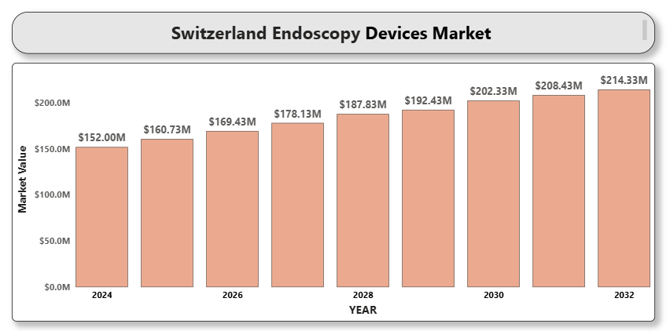

Switzerland’s endoscopy devices market is witnessing significant expansion driven by the growing preference for minimally invasive surgeries, increased geriatric population, and the rising incidence of gastrointestinal and colorectal cancers. The country benefits from a highly developed healthcare infrastructure, favorable reimbursement policies, and a high penetration of advanced endoscopic technologies. Moreover, technological advancements in HD visualization systems, robotic-assisted endoscopes, and single-use (disposable) devices are shaping the innovation landscape.

**Switzerland Endoscopy Devices Market Definition**

Endoscopy devices are medical tools used for examining the interior of a body cavity or organ using a minimally invasive approach. These devices are essential for both diagnostic and therapeutic procedures across various specialties such as gastroenterology, urology, pulmonology, gynecology, and orthopedics. Key product categories include flexible and rigid endoscopes, capsule endoscopes, disposable endoscopes, robotic-assisted systems, and supporting accessories like cameras, light sources, and insufflators. These are widely used in hospitals, specialty clinics, ambulatory surgical centers, and academic institutions.

Recent innovations such as AI-assisted image recognition, ultra-thin endoscopes, and disposable scopes for infection control are driving growth and adoption.

**Switzerland Endoscopy Devices Market Overview**

The endoscopy devices market in Switzerland is defined by early adoption of medical innovations, high procedural volumes, and government-supported digital health initiatives. A strong focus on cancer screening (especially colorectal) and digestive tract diagnostics contributes to rising demand for endoscopic interventions. Moreover, the market is supported by Swiss medical device manufacturers and research hubs focused on minimally invasive technologies.

However, challenges such as high device costs, training requirements for advanced systems, and procurement bottlenecks in public hospitals could impede faster market penetration. Nonetheless, public-private partnerships and growing investments in robotic endoscopy and AI-based imaging are expected to boost market opportunities.

**Switzerland Endoscopy Devices Market Segmentation Analysis**

**Market Segmentation by Product Type:**

* Flexible Endoscopes
* Rigid Endoscopes
* Capsule Endoscopes
* Disposable Endoscopes
* Robot-Assisted Endoscopes
* Visualization Systems (Camera, Light Source, Display)
* Endoscopic Accessories (Biopsy forceps, Trocars, Insufflators)

Flexible endoscopes lead the market due to their extensive use in GI and pulmonary procedures. Disposable endoscopes are gaining popularity, particularly in infection-sensitive departments like ICU and pulmonology. Robotic-assisted devices are an emerging niche.

**Market Segmentation by Application:**

* Gastrointestinal Endoscopy
* Laparoscopy
* A close-up of hands holding a tablet and a pen

  Description automatically generatedArthroscopy
* Urology Endoscopy
* ENT Endoscopy
* Gynecology Endoscopy
* Bronchoscopy
* Others

GI endoscopy holds the largest share due to increased prevalence of gastrointestinal disorders and robust screening protocols for colorectal cancer. Laparoscopy and arthroscopy follow, supported by growing demand for day-care surgeries.

**Market Segmentation by End User:**

* Hospitals
* Ambulatory Surgical Centers
* Specialty Clinics
* Academic & Research Institutions

Hospitals are the major consumers of endoscopy systems, owing to comprehensive diagnostic and surgical departments. However, ambulatory surgical centers are growing due to cost-efficiency and shorter patient stays.

**Market Segmentation by Region:**

* German-speaking Switzerland (Zurich, Basel, Bern)
* French-speaking Switzerland (Geneva, Lausanne)
* Italian-speaking Switzerland (Ticino)

German-speaking regions lead in procedure volume and technology adoption, driven by higher population density and larger healthcare infrastructure. French-speaking areas are also seeing growth in ambulatory care investments.

**Key Players**

The Switzerland endoscopy devices market is served by global giants and some strong regional manufacturers. Key players include:

* Karl Storz SE & Co. KG
* Olympus Corporation
* Medtronic plc
* Stryker Corporation
* Fujifilm Holdings Corporation
* Boston Scientific Corporation
* Smith & Nephew plc
* Richard Wolf GmbH
* Tecan Group Ltd. (Switzerland-based)

These companies compete on innovation, image quality, instrument flexibility, disposables, and bundled procedural solutions.

**Key Developments**

* **March 2024**: **Karl Storz** launched the next-gen **IMAGE1 S™ Rubina** system with enhanced 4K and NIR/ICG imaging for precision laparoscopy.
* **May 2024**: **Olympus** received Swissmedic approval for its **EVIS X1** endoscopy platform, enhancing AI-supported detection of colorectal polyps.

**Market Attractiveness**

Switzerland is a highly attractive market for endoscopy devices due to early adoption of minimally invasive procedures, high public healthcare investment, and robust screening programs. The country's aging population, combined with increasing cancer prevalence and high income levels, ensures strong procedural demand. Additionally, the push toward disposable and robotic systems for infection prevention and surgical accuracy presents opportunities for premium device manufacturers.

**Porter’s Five Forces**

* **Threat of New Entrants**: Moderate. High regulatory requirements and need for clinical validation limit entry, but software-based add-ons (AI/AR) offer entry points.
* **Bargaining Power of Suppliers**: Low to Moderate. OEM parts are widely available, though niche imaging and sensor components may give suppliers some leverage.
* **Bargaining Power of Buyers**: High. Swiss hospitals and centralized procurement groups negotiate pricing aggressively, favoring value-based procurement.
* **Threat of Substitutes**: Low. Imaging alternatives like CT/MRI are not procedural; endoscopy remains unique in combined diagnostic and therapeutic capability.
* **Industry Rivalry**: High. The market is dominated by multinational giants with overlapping product portfolios and frequent new product launches.

**TABLE OF CONTENTS**

1. **INTRODUCTION OF SWITZERLAND ENDOSCOPY DEVICES MARKET**  
   1.1 Overview of the Market  
   1.2 Scope of Report  
   1.3 Assumptions
2. **EXECUTIVE SUMMARY**
3. **A close-up of hands holding a tablet and a pen

   Description automatically generatedRESEARCH METHODOLOGY**  
   3.1 Data Mining  
   3.2 Validation  
   3.3 Primary Interviews  
   3.4 List of Data Sources
4. **SWITZERLAND ENDOSCOPY DEVICES MARKET OUTLOOK**  
   4.1 Overview  
   4.2 Market Dynamics  
   4.2.1 Drivers  
   4.2.2 Restraints  
   4.2.3 Opportunities  
   4.2.4 Trends  
   4.3 Porter’s Five Force Model  
   4.4 Value Chain Analysis
5. **SWITZERLAND ENDOSCOPY DEVICES MARKET, BY PRODUCT TYPE**  
   5.1 Flexible Endoscopes  
   5.2 Rigid Endoscopes  
   5.3 Capsule Endoscopes  
   5.4 Disposable Endoscopes  
   5.5 Robot-Assisted Endoscopes  
   5.6 Visualization Systems  
   5.7 Accessories
6. **SWITZERLAND ENDOSCOPY DEVICES MARKET, BY APPLICATION**  
   6.1 Gastrointestinal Endoscopy  
   6.2 Laparoscopy  
   6.3 Arthroscopy  
   6.4 Urology Endoscopy  
   6.5 ENT Endoscopy  
   6.6 Gynecology Endoscopy  
   6.7 Bronchoscopy  
   6.8 Others
7. **A close-up of hands holding a tablet and a pen

   Description automatically generatedSWITZERLAND ENDOSCOPY DEVICES MARKET, BY END USER**  
   7.1 Hospitals  
   7.2 Ambulatory Surgical Centers  
   7.3 Specialty Clinics  
   7.4 Academic & Research Institutes
8. **SWITZERLAND ENDOSCOPY DEVICES MARKET, BY REGION**  
   8.1 German-speaking Switzerland  
   8.2 French-speaking Switzerland  
   8.3 Italian-speaking Switzerland
9. **SWITZERLAND ENDOSCOPY DEVICES MARKET COMPETITIVE LANDSCAPE**  
   9.1 Overview  
   9.2 Company Market Ranking  
   9.3 Key Development Strategies

#### 10. COMPANY PROFILES 10.1 Karl Storz SE & Co. KG

10.1.1 Overview  
10.1.2 Financial Performance  
10.1.3 Product Outlook  
10.1.4 Key Developments

**10.2 Olympus Corporation**

10.2.1 Overview  
10.2.2 Financial Performance  
10.2.3 Product Outlook  
10.2.4 Key Developments

**10.3 Medtronic plc**

10.3.1 Overview  
10.3.2 Financial Performance  
10.3.3 Product Outlook  
10.3.4 Key Developments

**10.4 Stryker Corporation**

10.4.1 Overview  
10.4.2 Financial Performance  
10.4.3 Product Outlook  
10.4.4 Key Developments

**10.5 Fujifilm Holdings Corporation**

10.5.1 Overview  
10.5.2 Financial Performance  
10.5.3 Product Outlook  
10.5.4 Key Developments

**10.6 Boston Scientific Corporation**

10.6.1 Overview  
10.6.2 Financial Performance  
10.6.3 Product Outlook  
10.6.4 Key Developments

**10.7 Smith & Nephew plc**

10.7.1 Overview  
10.7.2 Financial Performance  
10.7.3 Product Outlook  
10.7.4 Key Developments

**10.8 Richard Wolf GmbH**

10.8.1 Overview  
10.8.2 Financial Performance  
10.8.3 Product Outlook  
10.8.4 Key Developments

**10.9 Tecan Group Ltd.**

10.9.2 Financial Performance  
10.9.3 Product Outlook  
10.9.4 Key Developments

1. **KEY DEVELOPMENTS**  
   11.1 Product Launches/Developments  
   11.2 Mergers and Acquisitions  
   11.3 Business Expansions  
   11.4 Partnerships and Collaborations
2. **A close-up of hands holding a tablet and a pen

   Description automatically generatedAPPENDIX**  
   12.1 Related Research